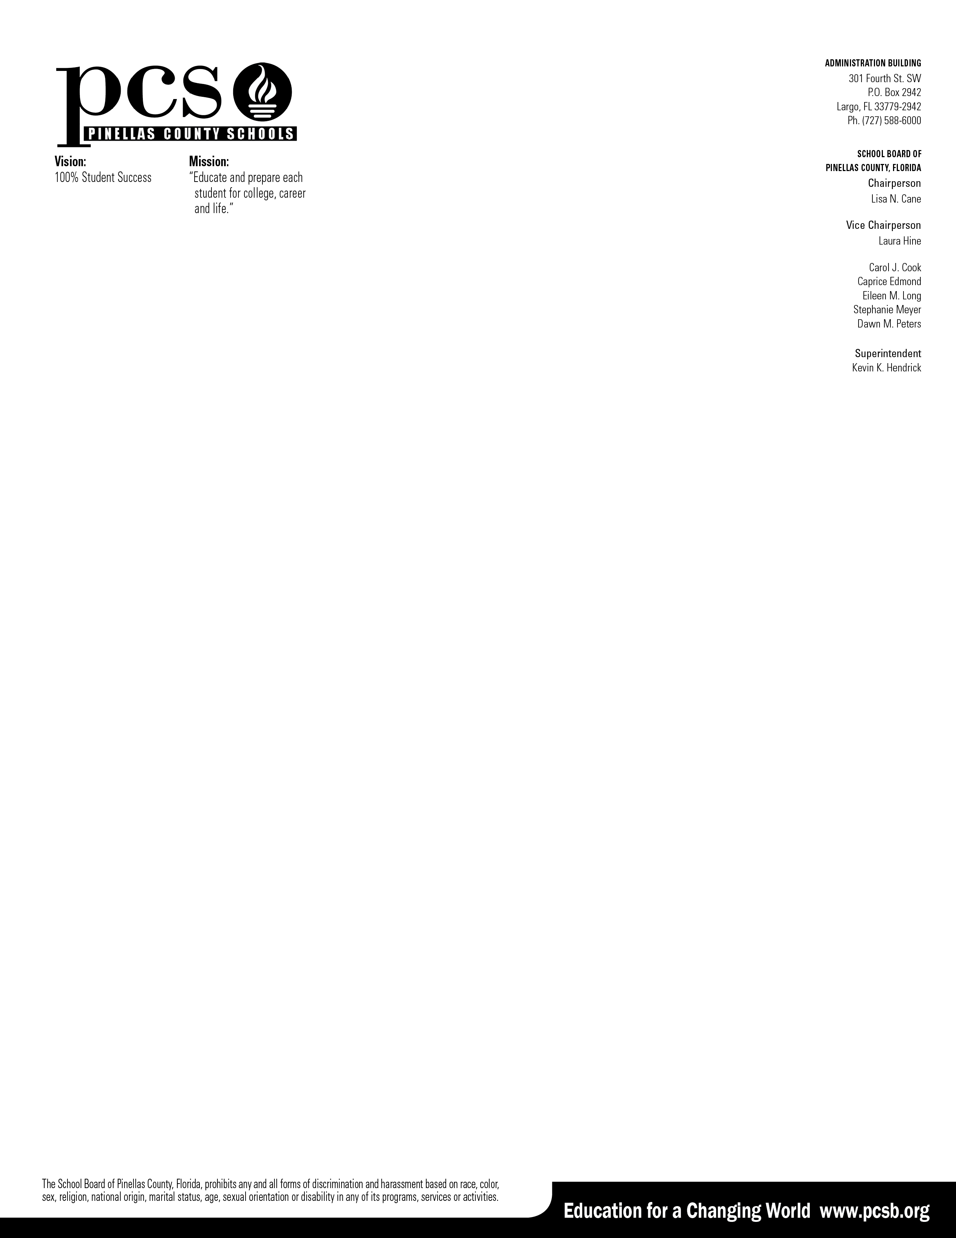

Dear Parent, 2/15/2023

The consent to disclose identifiable information for Medicaid purposes is a onetime requirement. This is currently located on your child’s clinic card. You are receiving this letter as Pinellas County Schools has a one-time consent on file. The schools are required to provide you with an annual notification of parental rights regarding Use of Public Benefits.

**This is an annual notification which outlines your rights and protections under Part B of the Individuals with Disabilities Act (IDEA).**

* Pinellas County School District is required to provide the special education and related services in your child’s IEP at **no cost** to you or your child.
* Medicaid Certified School Match is a Federal Program which reimburses school districts a portion of the costs associated for related services in the areas of Occupational Therapy, Physical Therapy, Speech and Language Therapy, Behavioral Health, and specialized transportation.
* If you choose not to provide your consent for Medicaid reimbursement purposes, your child will continue to receive all special education and related services under IDEA at **no cost** to you or your child.
* You may withdraw consent at any time providing written notice to the school district.
* Copies of records disclosed because of authorization to bill are available upon request.

Pinellas County Schools will bill Medicaid for the services that your child is receiving in the school system unless we hear from the legal guardian of the student withdrawing consent. The Medicaid Department will wait 10 days from the date of mailing to release the billing.

If you wish to withdraw consent, please contact the department at the number below; otherwise, no contact is necessary.

Please feel free to contact Pinellas County School System’s Medicaid Department at 727-588-6506 or 727-588-6494.

Thank you for your assistance in helping us to meet your child’s needs.

Sincerely,

Mary Ellen Barkman MPT

Medicaid Coordinator Pinellas County Schools